***GEOGRAPHIA CASSOVIENSIS X***X/20XX

# Manuscript title

Name SURNAME, Name SURNAME

***Abstract:*** *The abstract should be written as one paragraph (about 300 words). The abstract must state the overarching goal or main objective(s), as well as the purpose/rationale of the study in two or three sentences. This should be followed by succinct statements concerning the data used, approach adopted, and methods used. The scope and study design may also be mentioned. The key focus of the paper should be emphasized. Furthermore, one should point out what was achieved and/or what were the strengths and limitations of the studies. Any societal benefits and/or breakthroughs are also worth mentioning. The abstract must be self-contained. A reader should not have to read through the paper to understand it. Therefore, please define any acronyms used in the abstract or try to avoid them. For abstract and Keywords use the font Times New Roman, italics, size 10.*

***Keywords:*** *list of three to five keywords must be given, and placed after the Abstract, separated with comma (e.g. emigration, GIS, population structure)*

**Main body of text**

Text appropriately structured into sections (e.g., Introduction, Theory/Research background, Methods, Results, Discussion, Conclusions) and paragraphs. For title of each section, use the font Times New Roman, **bold**, size 11, 3 pt. spacing after paragraph. For the remaining part of the text, use Times New Roman, size 10, without any additional formatting except for 0.5 cm first line indentation at the beginning of each paragraph. It is advised to use automatic hyphenation (default setting in this template).

Tables and figures should be placed in the text. All kinds of graphics (graphs, schemes, maps, photos, etc.) must be labelled as figures with ascending numbering: *Fig. 1, Fig. 2,* etc. Tables are to be labelled as *Tab.* with ascending numbering: *Tab. 1, Tab. 2*, etc. Caption of a table is supposed to be placed above the table. Sources and notes of the table, if applicable, are placed below the table. Figure captions, sources and notes, if applicable, are all placed below figures. The captions must be self-contained. A reader should not have to read through the paper to understand it. For captions, sources and notes use the font Times New Roman, *italics*, size 10, centred. Each table or figure must be referenced in the text and placed after the first reference to it occurred in the text.

Most favourable, the tables are constructed directly in the MS Word, and left editable (i.e. not as raster images). Within the tables, the font Arial Narrow should be preferred using smaller size (8 or 9) to save the space. Please, use the same size and font in all tables in the manuscript.

Tables and figures should be placed in the text but figures must be sent also as numbered individual files in sufficient resolution in a common graphic format (TIFF, JPEG, EPS).

Figures are preferred in the greyscale but they are accepted in full colour if it increases informative value of the figure. After successful reviewing process, the issue of full colour/grayscale graphics should be consulted with editors prior to final manuscript submission.

Formulas and equations within text have to be editable in MS Word equation editor. Simple formulas and equations can be typed directly in the sentence. More complex formulas and equations should be placed in a separate line and centred. Formulas and equations should be numbered only if they need to be referenced in the text, as Eq. 1, Eq. 2, etc.

***Tab. 1.*** *Example of table placed in the text (caption above the table)*

|  |  |  |  |  |  |  |  |  |  |
| --- | --- | --- | --- | --- | --- | --- | --- | --- | --- |
|  | population | | | | | population growth index number in % | | | |
| **municipality** | **1869** | **1921** | **1950** | **1991** | **2011** | **1869 1921** | **1921 1950** | **1950 1991** | **1991 2011** |
| Čierna nad Tisou | x | x | x | 4 744 | 3 885 | x | x | x | 81.9 |
| Dobšiná | 5 508 | 4 622 | 4 363 | 4 569 | 5 702 | 83.9 | 94.4 | 104.7 | 124.8 |
| Giraltovce | 823 | 1 127 | 1 531 | 3 933 | 4 188 | 136.9 | 135.8 | 256.9 | 106.5 |
| Medzev | 5 091 | 4 191 | 3 611 | 3 871 | 4 261 | 82.3 | 86.2 | 107.2 | 110.1 |
| Podolínec | 1 663 | 1 707 | 1 604 | 2 908 | 3 257 | 102.6 | 94.0 | 181.3 | 112,0 |
| Spišská Stará Ves | 1 033 | 1 187 | 1 266 | 2 234 | 2 264 | 114.9 | 106.7 | 176.5 | 101.3 |
| Spišské Podhradie | 3 612 | 3 201 | 2 835 | 3 562 | 4 078 | 88.6 | 88.6 | 125.6 | 114.5 |
| Spišské Vlachy | 2 938 | 2 424 | 2 874 | 3 368 | 3 610 | 82.5 | 118.6 | 117.2 | 107.2 |
| Strážske | 1 564 | 1 616 | 1 399 | 4 255 | 4 416 | 103.3 | 86.6 | 304.1 | 103.8 |
| Veľký Šariš | 2 778 | 2 540 | 2 906 | 3 534 | 5 292 | 91.4 | 114.4 | 121.6 | 149.7 |
| Vysoké Tatry | x | x | 4 255 | 5 618 | 4 250 | x | x | 132.0 | 75.6 |
| **Slovakia** (in thousands) | **2 481.8** | **2 993.9** | **3 442.3** | **5 274.3** | **5 397.0** | **120.6** | **115.0** | **153.2** | **102.3** |

*Source:* *xxxxxxx (below table); Note: Indicate source as a reference to the sources in the list of references if possible*

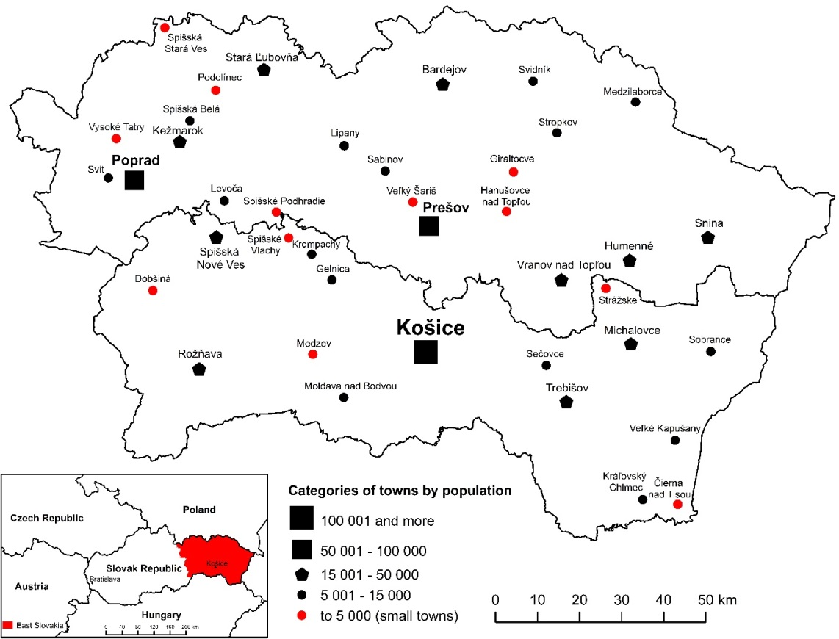

***Fig. 1.*** *Example of a figure placed in the text (caption below the figure); Source:* *xxx (below figure); Note: Indicate source as reference to the sources in the list of references if possible*

**Conclusions**

Conclusions should be both concise and precise, and include: (a) a description of the significant achievement or outcome of the study; (b) any new findings; (c) a statement of how knowledge is advanced; (d) an explanation of how the study is unique; and (e) the way forward. Vague subjective words should be avoided, while strengths and limitations should be clearly stated. In case of review papers, the conclusions should summarize the “state-of-art” of knowledge, knowledge gaps, and suggest ideas for going forward.

Sometimes, authors combine discussions and conclusions into a single section. This is unacceptable. The purpose of the conclusion is to show the real contribution of the research (i.e., how the research enhances overall knowledge of the field). In contrast, discussions are meant to show how one’s study compares with other studies, and in rare cases, how one’s study sets the stage for subsequent inquiries. We recommend discussing the results in a separate chapter or joining the discussion with the presentation of the results. Conclusions must be self-contained, i.e., a reader should not have to read through the paper to understand it and it would help if any acronyms were written in full.

**References**

*If available, indicate full DOI for each source. Examples of the Harvard style full citations in the list of references used in Geographia Cassoviensis:*

Book with one author

MESSI, S. 1985: *Tourism development in Albanian Riviera*. Tirana (Ministry of Economy and Tourism). DOI: <http://dx.doi.org/10.1146/annurev.so.13.080187.001021>.

CÁFAL, H. 2016: *Holistic geography in science*. London (Royal University of Geography). DOI: [http://dx.doi.org/10.1016/madona.so.13.005361.001016](http://dx.doi.org/10.1146/annurev.so.13.080187.001021).

Book with up to six authors

SCHWABIK, L., SAXA, P., VALICOVÁ, D., LIVINGSTONE, J., NÁČINOVÁ, J. 2007: *Distribution of university graduates in public sphere (7th edition)*. Bratislava (TLC Press). DOI: <https://doi.org/10.1007/BF03184400>.

BERRY, B. J., KASARDA, L., JOHN, D. 1977: *Contemporary urban ecology.* New York (Macmillan Publishing).

Book with more than six authors *(use et al. after the third author in any kind of source with more than six authors)*

LEONEL, S., MUSTER, D., MENDELOVA, H. et al. 2019: *Future of Geography in Western Europe*. Duesseldorf (Centre for Science Publishing house). DOI: [https://doi.org/10.1007/  
BF03184400](https://doi.org/10.1007/BF03184400).

TELEP, Z., RANDOM, F., KENEDY, U. et al. 2010: *New World Realms (5th edition)*. Košice (Institute of Geography). DOI: <http://dx.doi.org/10.1068/a37118>.

Edited book *(use “ed.” if there is one, or “eds.” if there are more editors)*

PAPADOPULOS, C. ed. 2018: *Launching new approaches in geography (2nd edition)*. Perth (Australian Geographic Publishing ltd.). DOI: <http://dx.doi.org/10.1068/a37118>.

PASTOR, A., KALVIN, D., LUTHER, J. eds. 2015: *Routes of geography of religion*. Wien (Scientific Publishing House). DOI: <http://dx.doi.org/10.1023/A:1007076000411>.

Transliterated source (book)

MARININA, A. M., RUDENKO, S. 2014: *Estimation of Nature-Resource Potential of Ukraine as a Basis for Management of Nature-Protection Activity.* Chernivtsi (Chernivtsi National University). DOI: <http://dx.doi.org/10.1023/A:1007076000411>. [Маринина А. М РУДЕНКО С. 2014: *Оцінка природно-ресурсного потенціалу України як основа менеджменту природоохоронної діяльності*. Чернівці (Чернівецький національний університет)].

Chapter in a book, conference proceedings, map in atlas *(use “pp.” to indicate range of pages of the chapter, use “p.” if whole cited chapter is only at one page)*

AUTHOR. O., RESEARCHER, T. 2018: Košice as a centre of IT industry development. In Editor, J. ed. *Economy development in Eastern Slovakia*. Košice (Economic Press), pp. 148-156. DOI: <http://dx.doi.org/10.1023/A:1007076000411>.

DREWETT, R., ROSSI, A. 1981: General urbanisation trends in Western Europe. In Klaasen, L. H., Molle, W. T. M., Paelinck, J. H. P. eds. *Dynamics of Urban Development*. Aldershot (Gower), pp. 199-236.

SHORTER, D. 2007: Beyond suburbanization. In Editor, H., Edit, N. eds. *Conference on Urban Development – Book of abstracts*. Pretoria (Uniba Press), p. 47.

CARTOGRAPHER, J. 2012: Distribution of caves, 1:10 000. In Researcher, H. ed. *Atlas of karst in Slovakia*. Rožňava (Carsology Centre), pp. 24-25.

Article in journal *(indicate only name, volume of the journal and range of pages of the article; indicate also the number of issue in the brackets after the volume, if the pages numbering is not continuous within one volume)*

PHIN LI, X., MAŇKOŠ, D. 1997: Migration from China to Central Europe. *Journal of Intercontinental Migration*, 34, 129-137. DOI: http://dx.doi.org/10.1068/d050151.

NOVÁK, J. 2017: Landslides in Slovak karst. *Geomorphology*, 12(3), 64-82.

LASER, D., KENNY, G., BONEY, M. et al. 2019: Adjusting aerial scanner to the cave environment. *Journal of Geoinformatics*, 2, 194-211.

Data or documents released by authority *(indicate authority as author, even if it is the same as publisher; if it is clear enough, it is possible to use abbreviation of the authority name as an author to make easier in-text referencing; if there is a set of data published annually or more frequently but regularly with the same name differing only in date, it is possible to indicate range of years instead of one year)*

GUS 2015: *Liczba ludnosci w gminach miejskich wedlug spisu w 2011 r*. Warszawa (GUS – Glowny urzad statystyczny).

NSO 2010-2015: *Annual international migration balance in the counties of Great Britain*. London (NSO – National Statistical Office).

SHMÚ 2000-2010: *Monthly perception at the meteorological stations in Podtatranská kotlina basin*. Bratislava (SHMÚ – Slovak Hydrometeorological Institute).

Ministry of Finance 2010: *Volume of import and export at the level of individual counties 2009.* Bratislava (Ministry of Finance).

EUROPEAN COMMISSION 2020: *Directive on traffic emissions.* Bruxelles (European Commission).

Thesis *(bachelor, diploma, dissertation…)*

GRADUATE, L. 2012: *Thesis about geography – diploma thesis*. San Francisco (Geography College).

HALENÁROVÁ, G. 1995: *Postoje študentov k vedeckej činnosti – dizertačná práca*. Poprad (Dizertačné centrum).

Internet sources, websites *(indicate date of citation only when information or data on cited website are likely to change in time)*

PRAGUE MUNICIPALITY 2016: Current state of shared tax income in urban districts. *Official Prague Website* [cit. 2015-07-31]. Retrieved from: http://finance.praha.cz/c/  
taxes/shared_up_to_date.html.

BALD-HEAD, I. 2015: The first paper ever in online journal. *Geographic Online Journal*, 1, 12-21. Retrieved from: http://geographic.online.journal/2015/1_1/bald-head.html.

***Acknowledgement: Is placed after References, font Times New Roman, Size 10, bold, italics.***

**Author1´s affiliation**

Name and Surname

Address

E-mail:

**Author2´s affiliation**

Name and Surname

Address

E-mail: